**//WAP to Check Even or Odd**

#include <stdio.h>

int main()

{

int n;

printf("Enter an integer: ");

scanf("%d",&n);

/* True if the number is perfectly

divisible by 2.*/

if(n % 2 == 0)

printf("%d is even.",n);

else

printf("%d is odd.",n);

getch();

}

**OUTPUT_____**

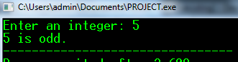**or**